~Asia-China-Mirror-Warring States-(475-221 BCE)-Arc 16-Inscription 22 Characters

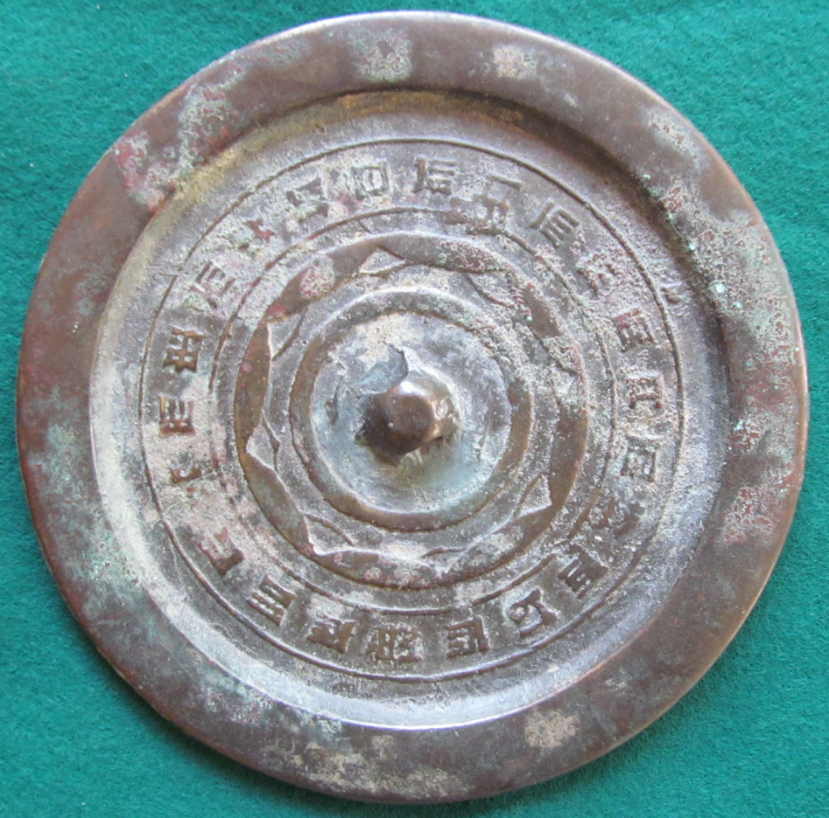

Warring States (475-221 BCE) Mirror. This design features a plain rim, missing a band of hachuring symbolizing the separation from the unknown void of the cosmos (the plain rim), and a 22 character inscription surrounds the missing hachuring. A central plain boss is surrounded with 8 continuous arcs conjoined with a separate non-continuous arc making a total of 16 arcs.